Joint Line Railfan Meet

Come out for a day of fun chasing trains with fellow train enthusiasts. Many trains traverse the BNSF and UP Joint Line daily, so we are sure to see some great train consists. Don’t forget your cameras, film, and scanners. Two master scanners will be tuned to the trains if you don’t have one. If you like trains, you will not want to miss this event.

Eat lunch at The Depot restaurant! The Depot is a railroad oriented restaurant and has some of the best food in the area. It is located right next to the Joint Line, so you can watch trains while you eat!

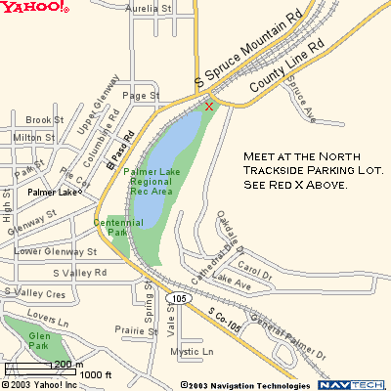

More information Contact:

Mike K.: mikek@trainshots.us
Lee R.: lr_trains@yahoo.com

NOTE: This event is held outdoors so please dress accordingly. Event will be cancelled in case of inclement weather.

